Les journées de la culture
IKEBANA — Japanese Floral Art Exhibition

Montréal, September 17th, 2026 — As part of the “Journées de la culture”, the Château Ramezay — Musée et site historique de Montréal invites you to attend the annual ikebana exhibition. Visitors will be able to admire these floral sculptures at the Château Ramezay during the annual exhibition created by students from the Montréal chapter of the Ikenobo school. These ephemeral works will be on display for free, on September 26th and 27th, 2026.
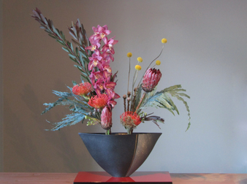
© Raynald Donais

What is Ikebana?
Ikebana, or the art of bringing flowers to life, is an ancient art that comes to us from Japan. The perfection of an arrangement, or rather a floral sculpture, lies first in the imagination and heart of its creator, then in the eye of the beholder. The Ikenobo school is the oldest school in Japan, both classical and modern. Founded by Senmu Ikenobo, it became popular in the 15th century, when the first writings on the art of flower arranging appeared. Visitors will also be invited to draw an arrangement that could be displayed in the corridor leading to the exhibition, which will be open to the public on Saturday from 10 a.m. to 4:30 p.m. and Sunday from 10 a.m. to 4 p.m.

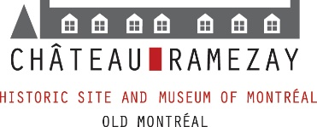

About
The Château Ramezay – Historic Site and Museum of Montréal is a non-profit organization which aims to preserve and make accessible the first building in Quebec to be classified an historical monument, as well as highlight a collection centered around the history of Montréal and the province. Founded in 1895, the Museum is certified by the Government of Quebec. Visit our website at chateauramezay.qc.ca and our Facebook page, facebook.com/Chateau.Ramezay.

- 30 -

Information:
Stella Rondeau - Communications coordinator
Email: agentcom@chateauramezay.qc.ca
Phone: 514 861-3708 ext. 225

